**There are 5 print screens each worth 20%**

1. Turn to page 103 and complete Question #1 Algorithm Workbench, be sure to have an output

**#1 Print screen the code with the output below here.**

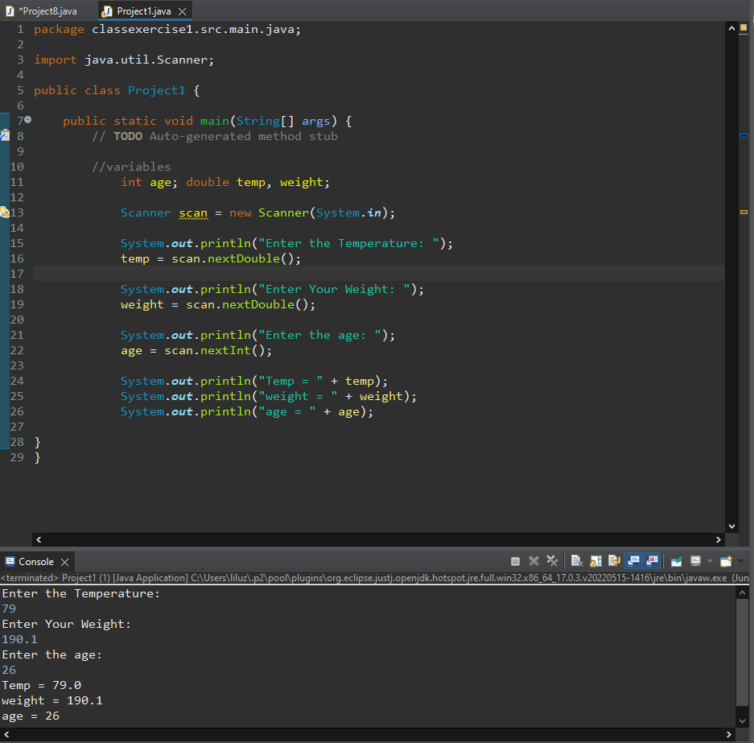

1. Turn to page 103 and complete Question #2 Algorithm Workbench, be sure to have an output

**#2 Print screen the code with the output below here.**

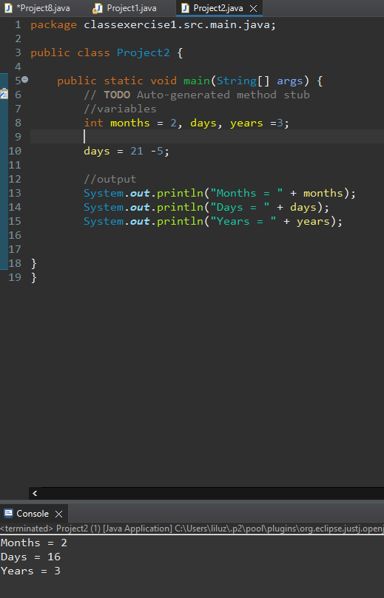

1. Turn to page 103 and complete Question #3 Algorithm Workbench, be sure to have an output

**#3 Print screen the code with the output below here.**

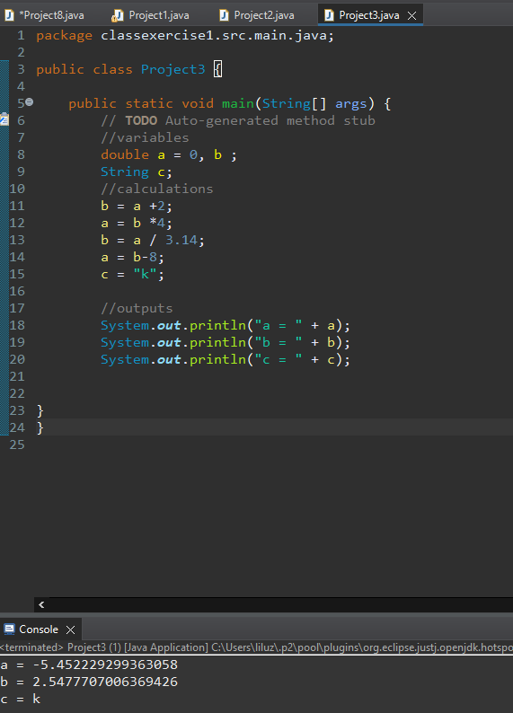

1. Turn to page 107 and complete Q9 the (Miles-per-Gallon) program

**#4 Print screen the code with the output below here.**

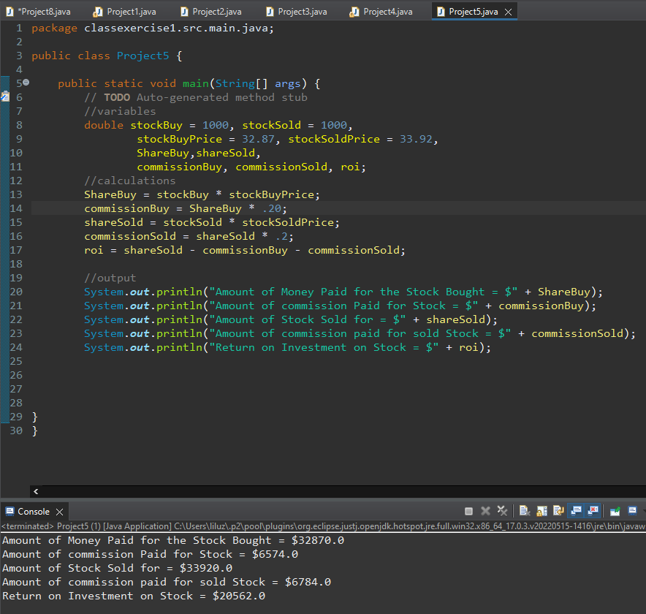

1. Turn to page 109 and complete Q19 the (Stock Transaction Program)

**#5 Print screen the code with the output below here.**

**Submit this document to Module 1 Homework #1**